PROJECT DESIGN PHASE
Problem – Solution Fit Documentation
Date | 22 September 2026
Team ID | SWTID-2026-2748
Project Name | AI BlogNest API
Maximum Marks | 2 Marks

1. Problem – Solution Fit
Problem–Solution Fit means identifying a real user problem and designing a solution that directly addresses it. For BlogNest, the focus is on simplifying the complete blogging workflow—from content creation and review to secure publishing, comments and AI-assisted content support.

2. Purpose
- Understand the needs of blog authors, editors, readers and administrators.
- Reduce the effort involved in creating, organizing, reviewing and publishing blog content.
- Provide a secure and structured platform for user and content management.
- Improve content productivity using AI-based blog generation and summarization.

3. Problem–Solution Fit Canvas
The completed canvas summarizes the target users, problems, constraints, behaviours and the BlogNest solution.
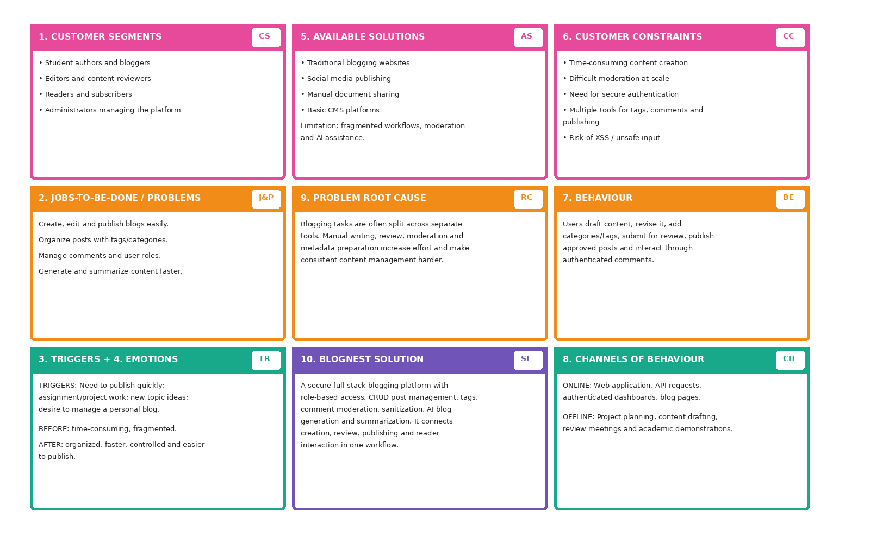
4. Detailed Problem Analysis
Area | BlogNest Description
Customer Segments | Student authors, independent bloggers, editors, readers and administrators.
Jobs to be Done | Create and edit posts, categorize content, moderate comments, publish approved posts and read/interact with blogs.
Existing Solutions | Traditional blogging sites, social platforms, document tools and basic CMS products.
Major Problems | Fragmented workflow, manual content preparation, moderation effort, security risks and lack of integrated AI assistance.
Root Cause | Creation, review, moderation, metadata and publishing are often handled through separate or disconnected workflows.
Customer Constraints | Limited time, need for simple interfaces, secure authentication, content quality requirements and protection against unsafe input.
Triggers | New content ideas, academic/project blogging, need for faster publication and the need to organize many posts.
Expected Behaviour | Draft → edit → tag/category → submit for review → approve → publish → comment/read.
Before State | Time-consuming, repetitive and fragmented content-management process.
After State | A single structured workflow with role control, moderation, security and AI-assisted content support.

5. Proposed BlogNest Solution
- Role-based access control for Admin, Editor, Author and Reader roles.
- CRUD-based blog engine for creating, editing, viewing and deleting posts according to permissions.
- Tag and category management for organizing blog content.
- Comment moderation using approved, pending and spam states.
- Input sanitization and validation to reduce XSS and unsafe NoSQL-style parameter manipulation risks.
- LLM-based blog generation from thematic inputs to support faster drafting.
- Summarization engine for producing abstracts and metadata summaries.
- REST/API-based backend architecture using controllers, routing and Mongoose models with MongoDB.

6. BlogNest System Architecture
The architecture connects users and role-based access with the API routing layer, controller workflows, database models, security checks and AI services.
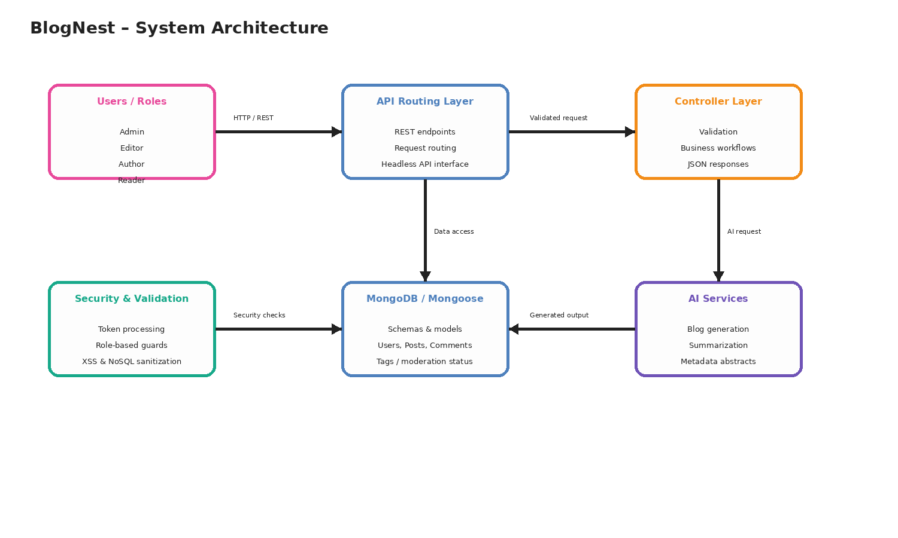
7. User Roles and Value Delivered
Role | Main Responsibilities | Value from BlogNest
Admin | Manage users, roles, comments and logs. | Centralized control and monitoring.
Editor | Review pending drafts, publish content and maintain categories. | Faster review and consistent content quality.
Author | Create and manage posts linked to the author's account. | Simple and controlled publishing workflow.
Reader | View published blogs and comment using an authenticated identity. | Organized reading and safer interaction.

8. Expected Outcome
BlogNest is designed to fit the needs of users who want a structured blogging environment without separating content creation, moderation, publishing, security and AI assistance into unrelated tools. The solution aims to make the blogging workflow easier to manage while maintaining role-based control and safer content handling.

9. Conclusion
The Problem–Solution Fit for BlogNest is based on a clear relationship between the identified blogging problems and the proposed platform features. By combining secure authentication, role-based workflows, CRUD operations, comment moderation, categorization, sanitization and AI-assisted generation and summarization, BlogNest provides an integrated solution for modern blog management.

10. References
BlogNest project requirements, system design and architecture prepared for the academic project documentation.

